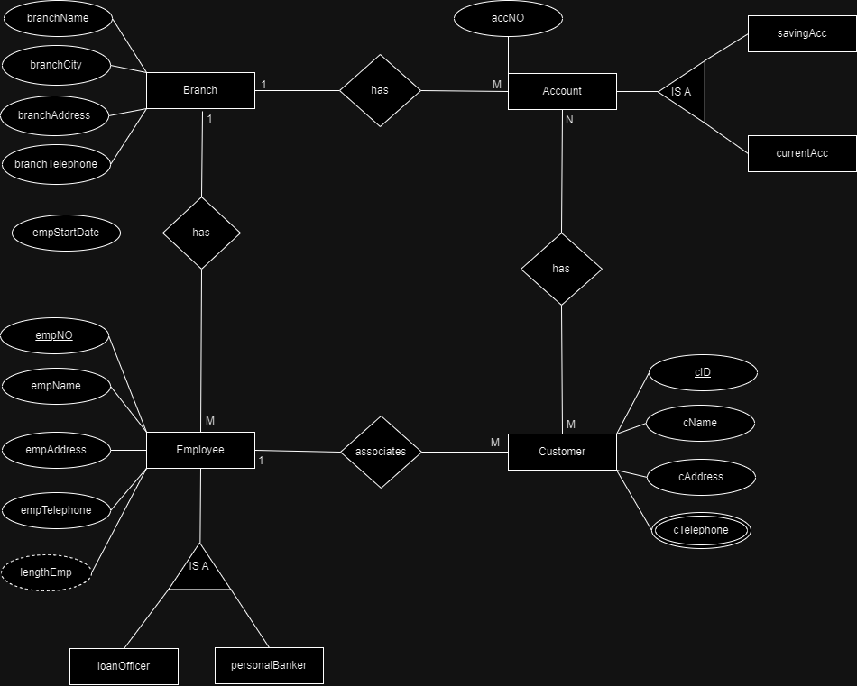

Assumptions

* **One Branch** has **Many Accounts.**
* **One Account** has a particular **One Branch.**
* **One Employee** associates with **Many Customers.**
* **One Customer** associates with a particular **One Employee.**
* **One Branch** has **Many Employees.**
* **One Employee** has a particular **One Branch.**
* **One Customer** can have **many Telephone Numbers.**